{{DATE}}

**{{CLIENT_NAME}}**

**{{ADDRESS}}**

**ATTENTION: {{CONTACT_PERSON}}**

Dear Sir/Madam,  
  
We take special pleasure in submitting our firm quotation for the KYOCERA DIGITAL COPIER TASKalfa MZ3200i as follows:

**BLACK ‘n WHITE COPY & PRINT, COLORED SCAN**

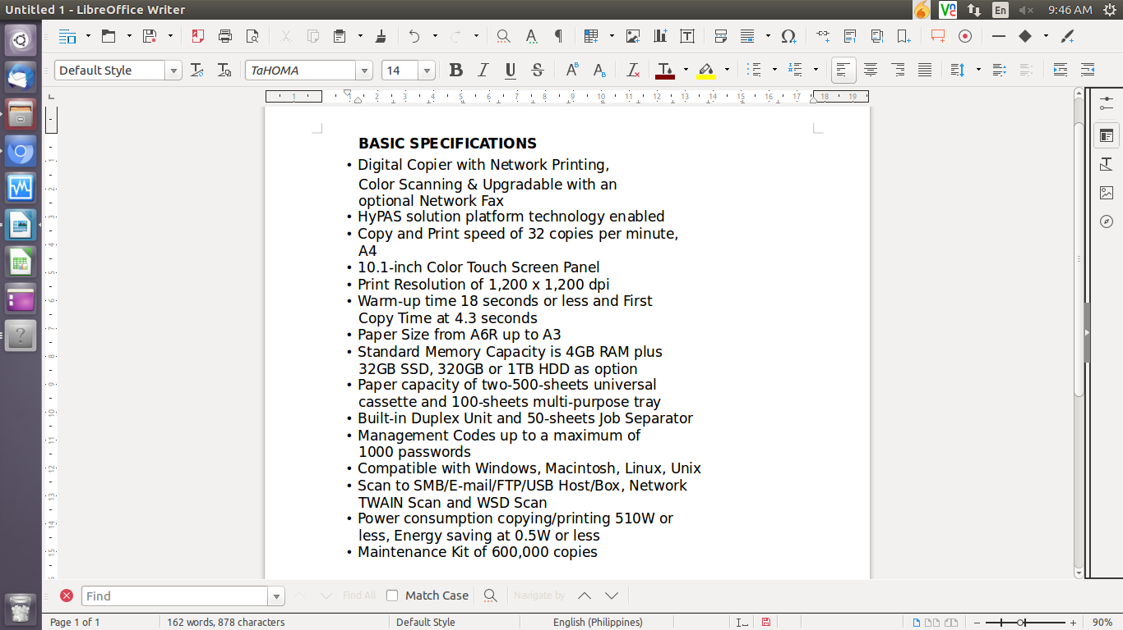

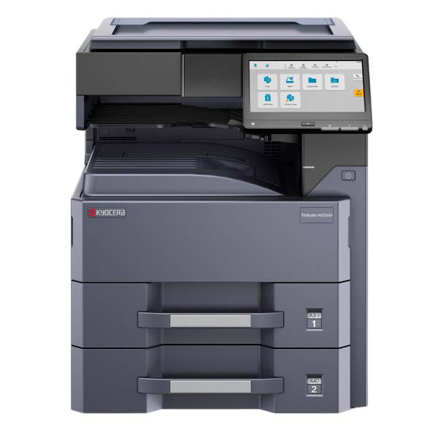

* **PRICE OF MACHINE (VAT INCLUSIVE)**

|  |  |  |
| --- | --- | --- |
| 1 unit of KYOCERA DIGITAL COPIER TASKalfa MZ3200i | Php | **216,700.00** |

**PROMO**

MACHINE REGULAR PRICE Php 216,700.00

TRADE-IN PROMO DISCOUNT Php 48,700.00

**TOTAL DISCOUNTED AMOUNT Php 168,000.00(less 15% in COD=Php 142,800.00)**

Php 14,000/MO. FOR 12 MONTHS (CREDIT CARD)

**OPTIONAL/ACCESSORIES (NOT INCLUDED IN MACHINE PRICE)**

DOCUMENT PROCESSOR (AUTO-FEEDER) Php 49,500.00 (LESS 10% IN COD)

ADDITIONAL PAPER CASSETTE (TWO 500-SHEET) Php 73,850.00 (LESS 10% IN COD)

WIFI DIRECT (WIRELESS LAN) Php 13,750.00 (LESS 10% IN COD)

STEEL TABLE/CABINET/PEDESTAL Php 6,200.00 (NET PRICE)

5 YEARS ADDITIONAL SERVICE Php 12,750.00 (NET OF 25% DISCOUNT)

LIFETIME SERVICE WARRANTY Php 14,400.00 (NET OF 25% DISCOUNT)

DOCUMENT FINISHER Php 136,500.00 (LESS 10% IN COD)

ATTACHMENT KIT (REQUIRED FOR DF) Php 8,350.00 (LESS 10% IN COD)

* **PRICE OF CONSUMABLES (VAT EXCLUSIVE)**

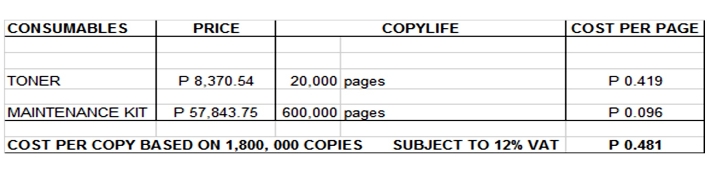

**Terms of Payment:** CASH  
  
**VALIDITY:** Prices are subject to change without prior notice. Please confirm with us prior to finalizing the order.  
  
**WARRANTY:**   
  
KYOCERA DIGITAL PLAIN PAPER COPIERS are guaranteed spare parts replacement FREE OF CHARGE for TWO (2) years, or up to 600,000 copies/print/scan whichever comes first.  
  
Warranty for accessories and options is ONE (1) year from the delivery date.  
  
We also assure prompt service whenever you need assistance. Repair service is FREE for TWO (2) years. Should our machine require prolonged service, we shall install a backup unit immediately for your convenience.  
  
Installation and Training of Personnel: Our expert service engineers install all our machines and they will be glad to train interested personnel on the detailed mechanics of the machine free of charge.

Moreover, the amount quoted above excludes the cost of any required tests or medical certifications such as, but not limited to Rapid tests, Antigen tests, and RT-PCR tests. The actual cost will be billed separately

We look forward to hearing from you soon. If you have any questions or concerns, please call us at 7618-0274.

Very truly yours, Conforme:

JAYPEE V. SONIEL __________________________________

SENIOR ACCOUNT EXECUTIVE II

09176240820 (Viber Ready)